PRESS RELEASE

One-stop shop CDMO Aenova: production and packaging of softgel capsules from a single source

- Aenova has started up a new canning and bottling line for soft gelatin capsules at its site in Cornu, Romania.
- The line has a capacity of 12 to 14 million bottles per year for bottle sizes DN 44-76 mm and H 55-165 mm.
- This provides customers with end-to-end service for the production and packaging of soft capsules.

Cornu, 20. July 2021 - Aenova produces and packages soft gelatin capsules and vegan soft capsules as a contract manufacturer for large, international pharmaceutical and nutritional supplement companies at its Cornu, Romania site with its subsidiary SWISSCAPS Romania s.r.l. With the production of various dosage forms of pharmaceuticals and food supplements, the Aenova Group is one of the leading contract manufacturers and developers in Europe and worldwide (Contract Development and Manufacturing Organisation, CDMO). A new can and bottle filling plant has now been commissioned in Cornu, which can fill around 12 to 14 million plastic or glass bottles per year.

At Aenova in Cornu, up to 10 billion softgel capsules are produced annually and can be packaged in blisters and cans or bottles. These include not only soft gelatin capsules for pharmaceuticals as well as dietary supplements, but also Aenova's vegan VegaGels®. With the newly installed filling line, the capacity of the packaging department with can and bottle filling will be significantly expanded. Aenova at the Cornu site is thus establishing itself as a "one-stop shop" for the production and packaging of soft capsules in all common variants and on customer request.

The new line packs in bottles with a diameter of 44 to 76 mm and a height of 55 to 165 mm, made of glass or plastic, with screw cap or so-called press lid. Special bottles can also be filled on request. For secondary packaging, all common variants of cardboard packaging with or without package insert including shrink film packaging and labeling are possible.

"The advantages of the "one-stop shop" for customers are obvious: with a competitive price, customer companies receive production and packaging from a single source, have only one contact person and only one manufacturing plant to qualify and register," explains Michael Ammann, Senior Vice President of the Softgel Capsules Business Unit and Managing Director at the Cornu site. This not only significantly reduces lead time, but also the overall on-time delivery (OTD). OTD at the Aenova site in Cornu is excellent at around 95%. "This means real added value for our customers," sums up Ammann.

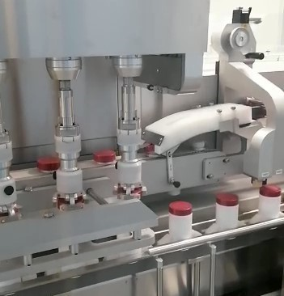

[Capture for Aenova_IMA_caper_hr.jpeg]
Production and packaging of soft capsules from a single source at the Aenova site in Cornu, Romania (Photo: Aenova).

About Aenova Group

The Aenova Group is a leading global contract manufacturer and development service provider for the pharmaceutical and healthcare industries. As a one-stop store, Aenova develops, produces and packages all common dosage forms, product groups and active ingredient classes of pharmaceuticals and dietary supplements for human and animal health: solid, semi-solid and liquid, sterile and non-sterile, high and low dose, OEB 1-5. With around 4,300 employees at 16 sites in Europe and the U.S., Aenova generates annual sales of around €750 million. www.aenova-group.com

Press Contact:

Dr. Susanne Knabe
Head of Corporate Communications & PR
Aenova Holding GmbH
Berger Straße 8-10
D-82319 Starnberg

Mobile: +49 170 22 368 42
E-mail: susanne.knabe@aenova-group.com

