**PRESS RELEASE**

**Aenova increases capacity for tablet production in the area of highly potent, hormone-containing active ingredients**

* **Aenova expands production of highly potent oncology drugs (up to OEB 5) with new tablet press.**
* **The fully automatic, online and process integrated control significantly increases process efficiency and enhances safety and product quality.**
* **This will enable the output of tablets for cytostatics, immunosuppressants and hormone-containing preparations at the Regensburg site to be increased to almost 1 million tablets per hour.**

Regensburg, February 02, 2021. The market for tablets with highly active ingredients, such as those in cytostatics, immunosuppressants or hormone-containing products, is growing rapidly. This development places the highest demands on production as well as on personnel safety. As a leading contract manufacturer for the pharmaceutical and healthcare industry, the Aenova Group also produces in the area of these so-called HPAPIs (High Potency Active Pharmaceutical Ingredients). The Aenova site in Regensburg is the Center of Excellence within the Aenova Group for the production of cytostatics/cytotoxics, immunosuppressants and various hormone-containing preparations. In order to meet the increasing demand of customers for preparations in the oncological environment with highly potent active ingredients, a third, high-performance tablet press including integrated automatic in-process control has now been put into operation, thus taking the next step towards a modern and efficient equipment park. With an investment of around € 500,000 and now a total of three identical, automated tablet press lines, Aenova can significantly increase capacity at the Regensburg site and in future produce up to 1 million tablets per hour in the field of highly potent products.

The tablet presses are connected online with three combination upward dedusters (deduster and metal check) and the automatic in-process control equipment. This enables the weight, dimensions and breaking strength of tablets drawn at defined times to be checked regularly and fully automatically. "This way, the quality of our products is regularly assessed in short cycles throughout the entire pressing process. For the significantly increased capacity achieved by using multiple dies, this is particularly important to ensure both quantity and quality," explains Dr. Christoph Stuhldreher, Head of Production at Aenova in Regensburg.

The automatic online and in-process control is an essential addition precisely because in the area of highly potent products up to the OEB-5 class, special protection must be guaranteed due to the hazard potential for the production personnel. This so-called containment in the area of HPAPIs is fully ensured at Aenova. The use of automatic online in-process control equipment now enables an uninterrupted, regulation-compliant and quality-assured manufacturing process for the tablets, independent of occupational safety regulations.

"With these technological improvements, we can demonstrate in our equipment our strong competence and many years of experience in the field of highly effective and oncological products in almost all dosage forms," adds Oliver Schmied, Managing Director of Aenova's Regensburg site. "Customer demand for cytostatics and cytotoxics, immunosuppressants and hormone-containing products has increased enormously. This way we can supply them quickly - up to OEB 5 and with many international certifications. Not every CDMO (Contract Development and Manufacturing Organization) can do that," Oliver Schmied continues.

"The implemented expansions are related to the strategic positioning of the Regensburg site as Center of Excellence HPAPI and Oncology Products within the Aenova Group. For this purpose, an extension building for the so-called HPAPIs (High Potency Active Pharmaceutical Ingredients) is planned to be built until 2022 as well as an expansion of the production capacities for hard capsules for high-potency products," explains Christine Beck, SVP of the Solids Business Unit at the Aenova Group.

Aenova in Regensburg produces and packages almost all dosage forms such as solid forms (tablets, film-coated tablets, capsules) as well as semi-solid forms (such as creams, ointments, gels), but also liquid forms (e.g. nasal sprays). In addition, the plant is a CDMO service provider for the entire product cycle: from analytical transfer, development and validation to commercial production, packaging, serialization and aggregation.

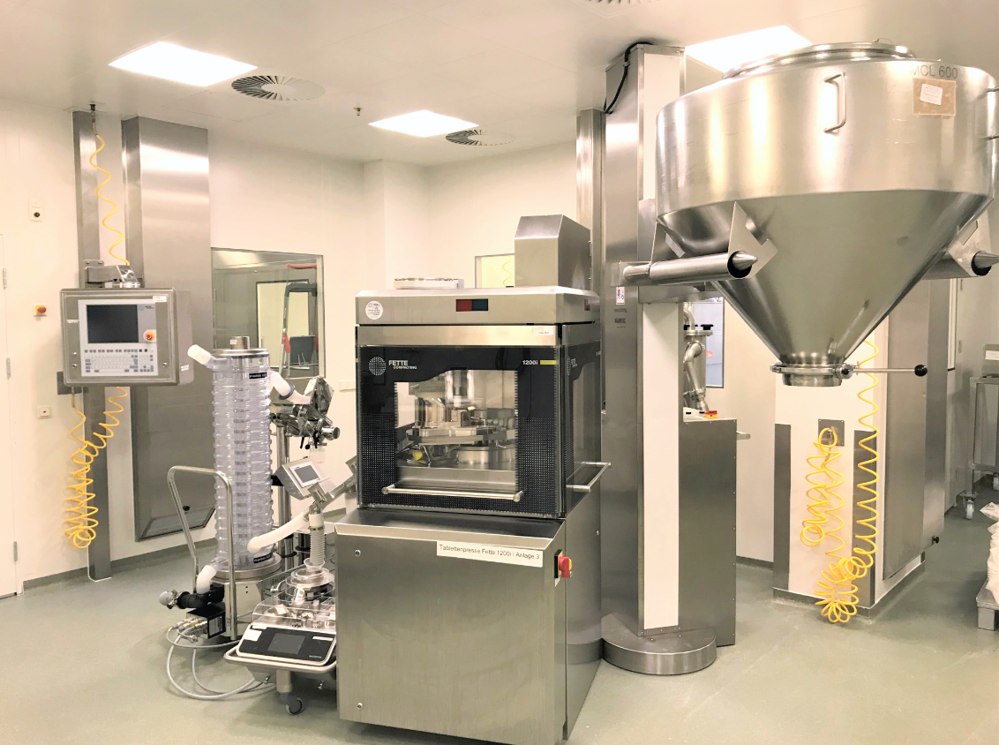

[Caption for picture Aenova_Tablettenpresse_Regensburg_1.jpeg]

The new tablet press at Aenova in Regensburg for highly potent active ingredients enables flexible high containment production. (Photo: Aenova Group)

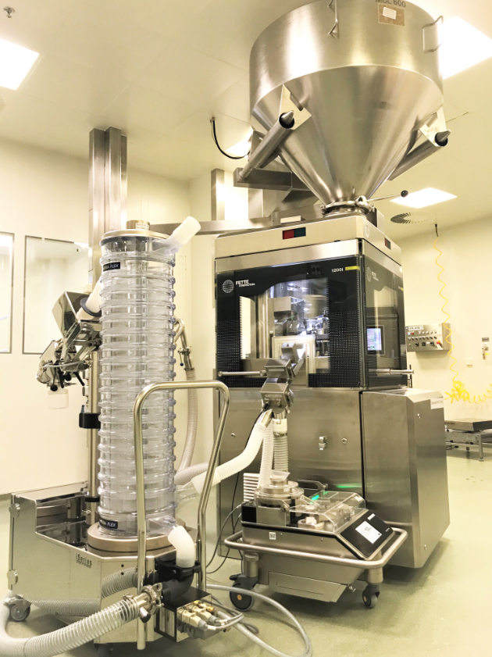

[Caption for picture Aenova_Tablettenpresse_Regensburg_2.jpeg]

At Aenova in Regensburg, almost 1 million tablets per hour can now be produced in the field of highly potent products. (Photo: Aenova Group)

**About Aenova Group**

The Aenova Group is a leading global contract manufacturer and development service provider for the pharmaceutical and healthcare industries. As a one-stop store, Aenova develops, produces and packages all common dosage forms, product groups and active ingredient classes of pharmaceuticals and dietary supplements for human and animal health: solid, semi-solid and liquid, sterile and non-sterile, high and low dose, OEB 1-5. With around 4,300 employees at 16 sites in Europe and the U.S., Aenova generates annual sales of around €750 million. [www.aenova-group.com](http://www.aenova-group.com)

**Press Contact:**

Dr. Susanne Knabe  
Head of Corporate Communications & PR

Aenova Holding GmbH

Berger Straße 8-10

D-82319 Starnberg

Tel: +49 8151 9987-135

Mobile: +49 170 22 368 42

E-mail: [susanne.knabe@aenova-group.com](mailto:susanne.knabe@aenova-group.com)