PRESS RELEASE

**Aenova publishes white paper on "Innovations in drug formulations" in cooperation with c&en**

Starnberg, 28 September 2022 - For an API (active pharmaceutical ingredient), i.e. the active pharmaceutical ingredient of a drug, to have an optimal effect on the patient, the formulation is an essential component. It therefore matters how the active ingredient is "wrapped" - e.g. as a tablet, capsule or powder. The drug production methods used in this process are constantly evolving, and Aenova, as one of the world's leading CDMOs (Contract Development and Manufacturing Organization), offers its customers in the pharmaceutical industry innovative formulation solutions - with the aim of further optimizing the efficacy and tolerability of drugs.

In collaboration with the renowned expert portal c&en, journal of the American Chemical Society, Aenova has now created a white paper specifically on the topic of how innovations in solid dosage formulation can be particularly promoted through partnerships. Title of the whitepaper "**Formulation Innovation: Partnerships Usher in Next Wave of Solid Dosage Forms**".

Some advanced active ingredients are not compatible with standard formulations due to problems with stability, solubility or other physicochemical properties. This white paper discusses innovative approaches to the formulation of solid dosage forms as well as in terms of novel therapy-enhancing delivery systems, e.g. dry powder inhalers with special capsules for asthma patients.

Numerous innovative manufacturing techniques can be used to improve the bioavailability and thus the efficacy of drugs. For example, the white paper describes "hot melt extrusion" for active ingredients with low bioavailability, polymer encapsulation with minispheres for sustained release (see figures 1 and 2), as well as coprecipitation and other technologies.

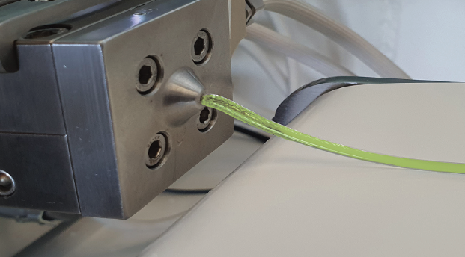

Figure 1: Hot melt extrusion technique for the production of solids with optimized solubility (Figure: Aenova).

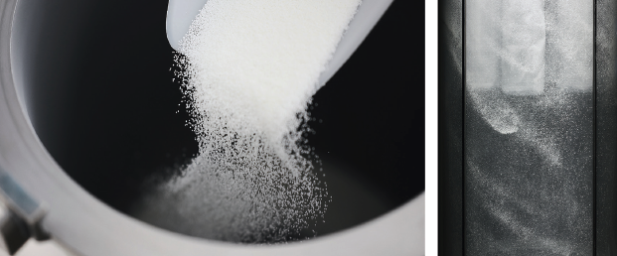

Figure 2: Coating of small spheres (microspheres) with polymers for sustained or targeted release formulations (Figure: Aenova).

Aenova offers its customers a full service portfolio for innovative oral solid dosage form technologies from development to commercial production.

The white paper "Formulation Innovation: Partnerships Usher in Next Wave of Solid Dosage Forms" can be requested free of charge by sending an e-mail to: [contact-sales@aenova-group.com](mailto:contact-sales@aenova-group.com) or with [this link.](https://connect.acspubs.org/Aenova_CDMOPartnerships?partnerref=CENAenova)

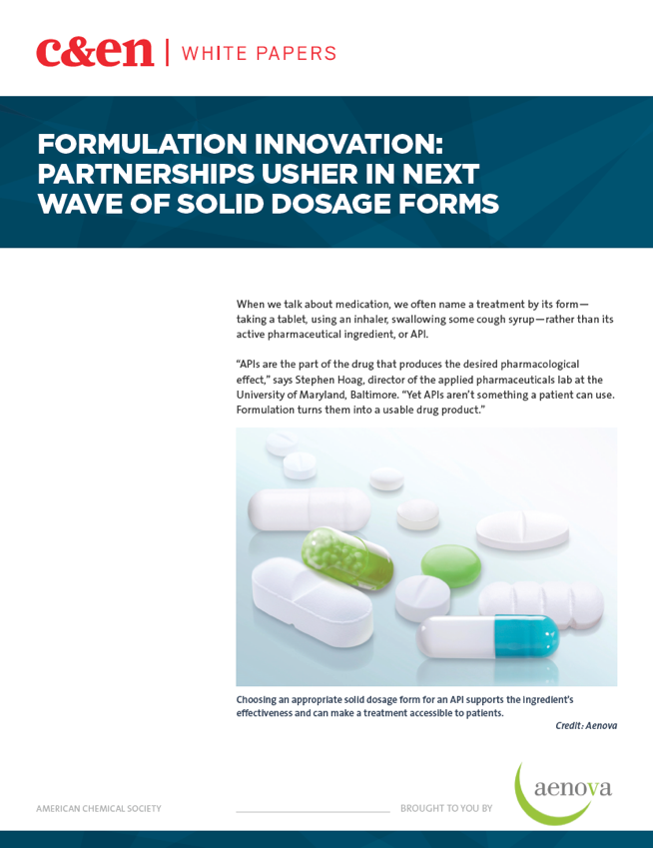

**About Aenova Group**

The Aenova Group is a leading global contract manufacturer and development service provider for the pharmaceutical and healthcare industries. As a full-service provider, Aenova develops, produces and packages all common dosage forms, product groups and active ingredient classes of pharmaceuticals and food supplements for human and animal health: solid, semi-solid and liquid, sterile and non-sterile, high and low dose, OEB 1-5, and Fill&Finish of biologics/vaccines up to BSL-2. Around 4,200 employees at 16 locations worldwide contribute to Aenova's success.

**Press contact**

Dr. Susanne Knabe  
Head of Corporate Communication & PR

Aenova Holding GmbH

Berger Straße 8 - 10

D-82319 Starnberg

Mobile: +49 170 22 368 42

E-mail: [susanne.knabe@aenova-group.com](mailto:susanne.knabe@aenova-group.com)