PRESS RELEASE

**Micro-dosed capsule filling and dry powder inhalation are key innovation topics at Aenova**

Münster, October 26, 2022 - Dry powder inhalation using a DPI device (dry powder inhaler) is becoming more and more important for patient care in view of the worldwide increase in lung and respiratory diseases. The need for therapeutics for bronchial asthma and COPD (chronic obstructive pulmonary disease), for example, is also rising worldwide. Many of the therapies need to be used by patients for life, which underscores the need to make DPI cost-effectively available and easy for patients to use.

The galenic formulation of the active ingredients is particularly challenging, as the inhalable aerosol particles must have an aerodynamic diameter of 1 to 5 µm over the entire shelf life of the product in order to ensure adequate pulmonary mobility. For this purpose, Aenova has a state-of-the-art DPI capsule production and proven expertise from development to commercial production.

With state-of-the-art micro-dosing technology, Aenova ensures full scalability for DPI capsule products (flexible batch sizes from 0.5 kg to commercial sizes). In addition, there are product-specific analysis options according to EP / USP as well as specific blistering and combination packaging solutions.

Together with the customer, Aenova creates a purposeful concept phase and a product design precisely tailored to the requirements - including analytical method development, ICH stability testing, development and validation of the manufacturing process to obtain a safe and stable effect of the drug product.

The modern high-speed capsule filling machine at the Aenova site in Münster is suitable for product dosing in the range of 5 mg to 50 mg per capsule and is equipped with 100% control, which enables in-process control of each individual capsule and ensures the highest quality of the final low-dose product. If required, additional modular dosing units can be integrated to combine also different dosage forms, e.g. pellets and powder, tablets and pellets and other variants.

"We are very proud to be able to offer such a comprehensive service from development to commercial production in the field of dry powder inhalation and micro-dosed capsule filling of highly potent active ingredients," says *Dr. Gereon Rau, Team Lead - Capsule Technologies* at Aenova. "Our innovative solutions and reliable production and delivery capabilities are of benefit to our customers in the pharmaceutical industry and, last but not least, to patients with respiratory diseases worldwide."

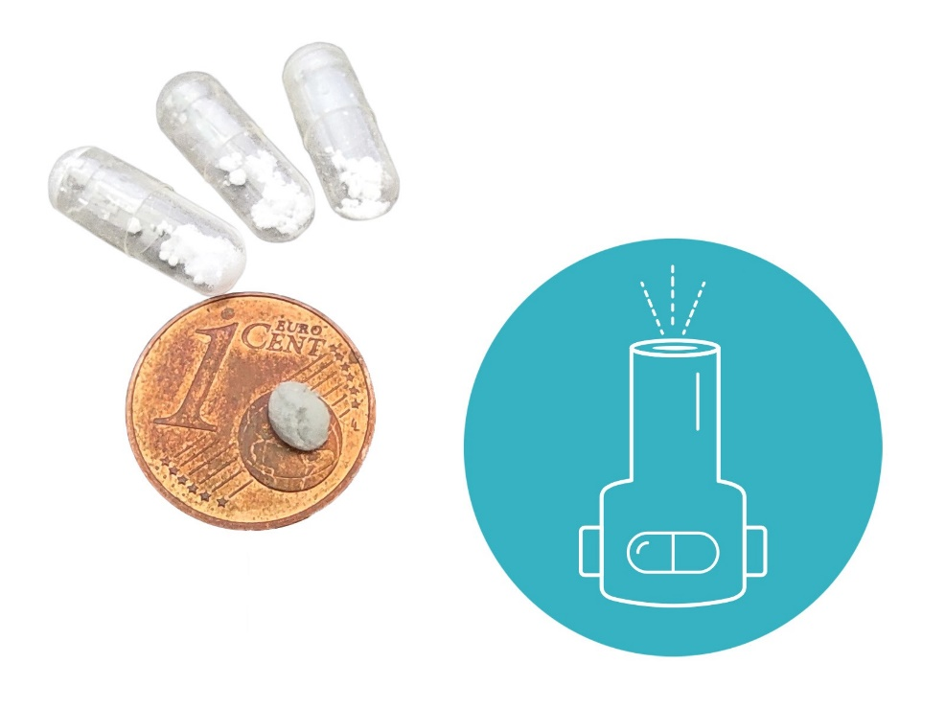

Low-dose capsule filling, e.g. for inhalers, enables better therapy for patients with respiratory diseases (Figure: Aenova).

Ein Bild, das drinnen, Wand, Boden, Raum enthält.

State-of-the-art capsule filling machine for low-dose capsule filling at the Aenova site in Münster (Photo: Aenova)

**About Aenova Group**

The Aenova Group is a leading global contract manufacturer and development service provider for the pharmaceutical and healthcare industry. As a one-stop shop, Aenova develops, produces and packages all common dosage forms, product groups and active ingredient classes from pharmaceuticals to dietary supplements for human and animal health: solid, semi-solid and liquid, sterile and non-sterile, high and low dose, OEB 1 to 5 (Occupational Exposure Band). Approximately 4,200 employees at 16 sites in Europe and the U.S. contribute to the company's success. For more information, visit www.aenova-group.com.

**Press contact:**

Dr. Susanne Knabe  
Head of Corporate Communication & PR

Aenova Holding GmbH

Berger Straße 8-10

D-82319 Starnberg

Mobile: +49 170 22 368 42

Email: [susanne.knabe@aenova-group.com](mailto:susanne.knabe@aenova-group.com)