PRESS RELEASE

Aenova Christmas campaign:
employees donate to social institutions

Aenova employees collected donations in kind and money for social institutions in Starnberg at the beginning of December 2022. These donations will be used to support two organizations that help disadvantaged people.

Starnberg, December 16, 2022 - The year 2022 is and was a challenging year worldwide. The Corona pandemic was followed by the Ukraine war. Energy supply, price increases and inflation have since affected many people and organizations, including in Germany. Disadvantaged and socially weaker people are particularly affected.

Therefore, Aenova, a leading global contract developer and manufacturer for the pharmaceutical and healthcare industries, organized two donation initiatives as a Christmas campaign. At Aenova's headquarters in Starnberg, employees collected donations in kind and a sum of money for two local social institutions: Winter clothing and shoes for children and adults, toys, tableware and household goods.

Both institutions are very grateful for the spontaneous donations, especially now in the cold season and with partly declining donations in recent months. "We are pleased that we can support people in need and the socially disadvantaged with our joint contributions. A big thank you to our employees who made these joint campaigns possible," explains Dr. Susanne Knabe, Head of Corporate Communication at Aenova. "In the coming year, we plan to expand these initiatives."

As part of its corporate social responsibility strategy, the company, with its 16 sites worldwide, is primarily involved in the local environment and supports charitable initiatives at the individual company locations.

There are social institutions that prefer to work in silence and do not want to be named. A separate report will follow on the presentation of the check for the cash donation.

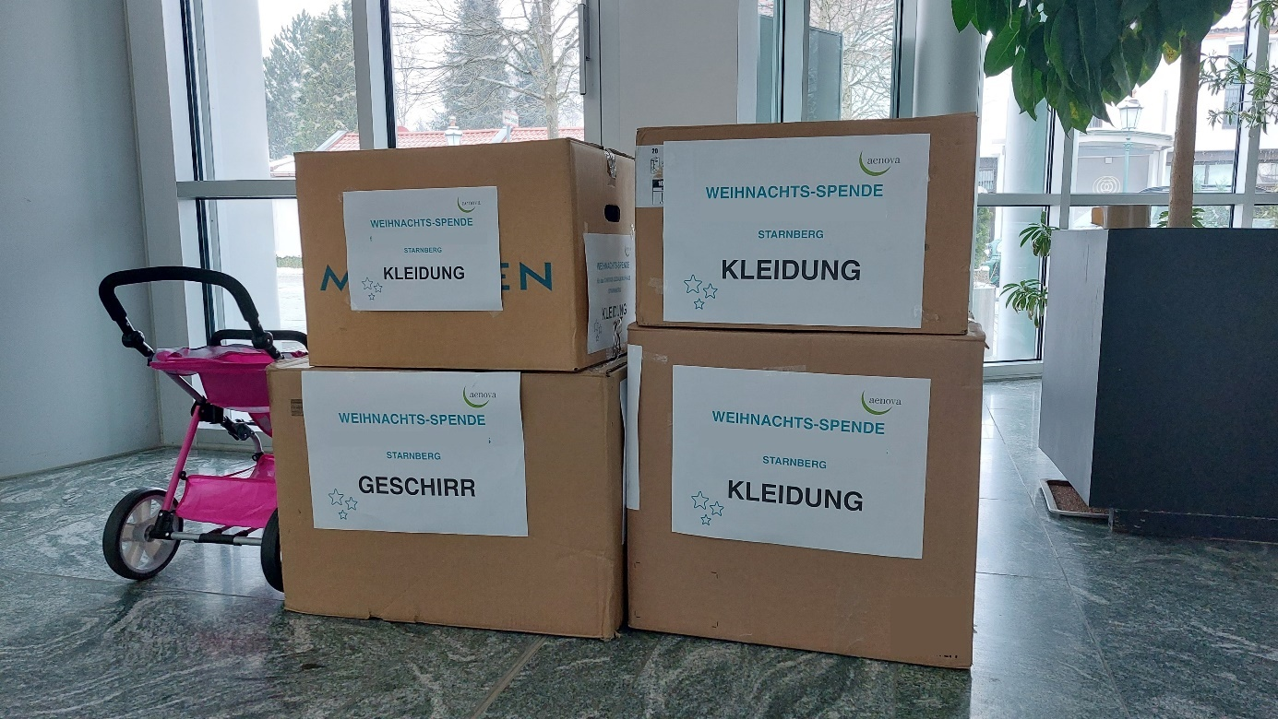
Aenova employees collected for charity at Christmas 2022. (Photo: Aenova)

About Aenova Group

The Aenova Group is a leading global contract manufacturer and development service provider for the pharmaceutical and healthcare industry. As a one-stop store, Aenova develops, produces and packages all common dosage forms, product groups and active ingredient classes from pharmaceuticals to dietary supplements for human and animal health: solid, semi-solid and liquid, sterile and non-sterile, high and low dose, OEB 1 to 5 (Occupational Exposure Band). Approximately 4,200 employees at 16 sites in Europe and the U.S. contribute to the company's success. For more information, visit www.aenova-group.com.

Press contact

Dr. Susanne Knabe
Head of Corporate Communication & PR
Aenova Holding GmbH
Berger Street 8 - 10
D-82319 Starnberg

Mobile: +49 170 22 368 42
E-mail: susanne.knabe@aenova-group.com

