PRESS RELEASE

**Aenova wins ifm/GIB Supply Chain Management Award**

* **As a global leader in contract development and manufacturing, Aenova focuses on innovation, including digital transformation of supply chain management.**
* **As a successor system to SAP APO, the planning and operations module from the GIB Suite was implemented at three sites. The new solution significantly optimizes planning and scheduling efforts end to end.**
* **For this, Aenova received one of the three prestigious SCM Awards from ifm (formerly GIB).**

Starnberg, July 15, 2022 - As one of the leading contract developers and manufacturers for the pharmaceutical and healthcare industry, the Aenova Group is constantly working on innovations and optimizations. This also applies to the systems around supply chain management.

As a successor system to SAP APO, the SAP-integrated Planning module from the GIB Suite has been implemented at the Münster and Wolfratshausen sites and in Latina (Italy) since fall 2020. In a second step, the Operations module was gradually rolled out at all three sites to optimize the processes in purchasing and scheduling. As a result, all former APO processes have been effectively replaced. The largest German Aenova site in Tittmoning has also been working with the Operations module since July 2022 to handle its complex purchasing processes. In addition to the operative day-to-day business, all locations now have the option of displaying requirements, consumption, backlogs or inventories graphically and in tabular form.

All locations have heterogeneous IT structures that have grown over many years and a far-reaching consolidation of settings, customizing and interfaces was necessary. In order to reduce the effort in planning and scheduling and at the same time optimize the SCM processes, the Aenova Group decided with the software manufacturer ifm (formerly GIB) to choose the GIB Suite Tools for scheduling and planning as a replacement for the existing SAP APO. The entire conversion - from conception to test phases to implementation - took only 24 months, including the development and implementation of special functions, e.g. for the optimized planning of setup and cleaning times.

The new solution has significantly reduced planning and scheduling costs. Processes have been smoothed and additional work has been significantly reduced, which has also led to a sustainable increase in staff satisfaction. Overall, Aenova has succeeded in optimizing SAP-controlled supply chain processes end-to-end thanks to the ifm solutions. Since the two tools were introduced in record time, Excel planning has become a thing of the past. The success achieved with the software has just been recognized with an SCM award from GIB.

"The Aenova teams at the individual sites as well as the great support from the experts at GIB have brought us resounding success," says a delighted Frank Augustin, project manager and long-time SAP expert at the Aenova Group.

"Optimized logistics and smooth supply chain management are crucial competitive advantages, especially for us as a contract manufacturer, and a weighty part of our Digital Transformation journey," adds Damir Juricic, Vice President Corporate IT at Aenova Group. "Congratulations to the whole team!"

From 2023, the controlling module from the GIB Suite will also enter the test phase for a few months. This module can be used to classify and analyze inventories according to A B C, slow and fast movers, core stocks, store stocks, and so on. Here, the Aenova project team expects another major benefit.

**Image material**

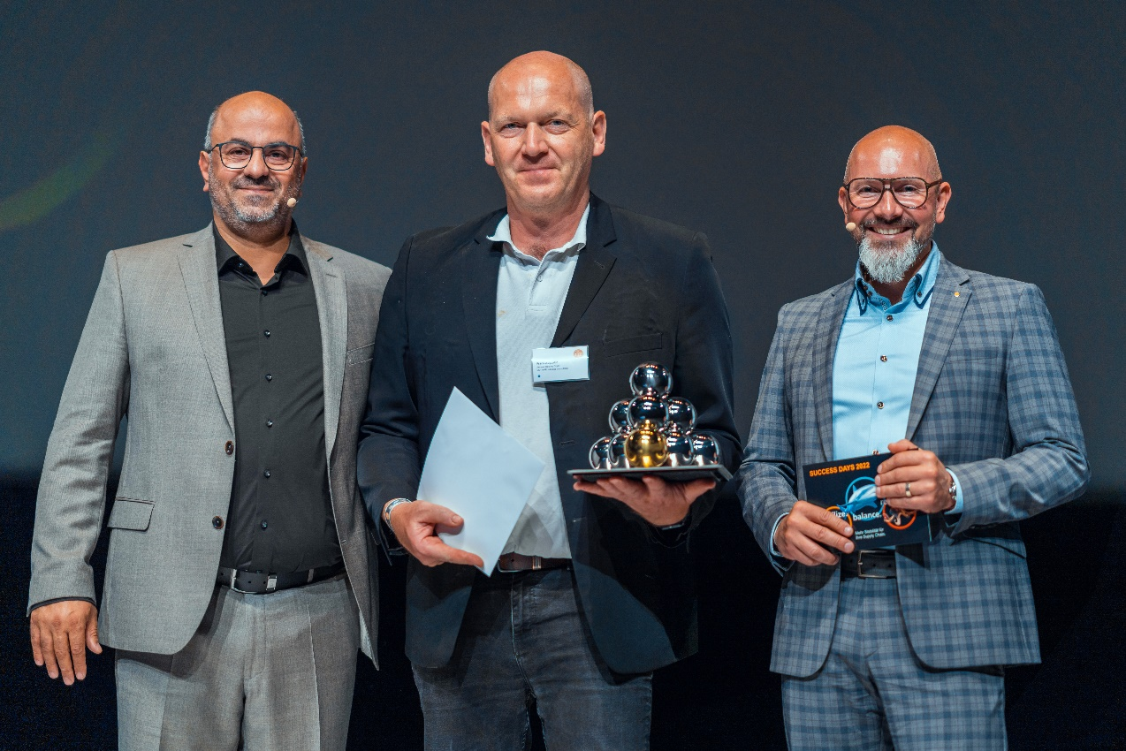

Caption: Frank Augustin, Aenova Group, is pleased to accept the award from Bilgin Kilic (left) and Björn Dunkel (right, both ifm Business Solutions) (Photo: IFM Business Solutions / G. Bender)

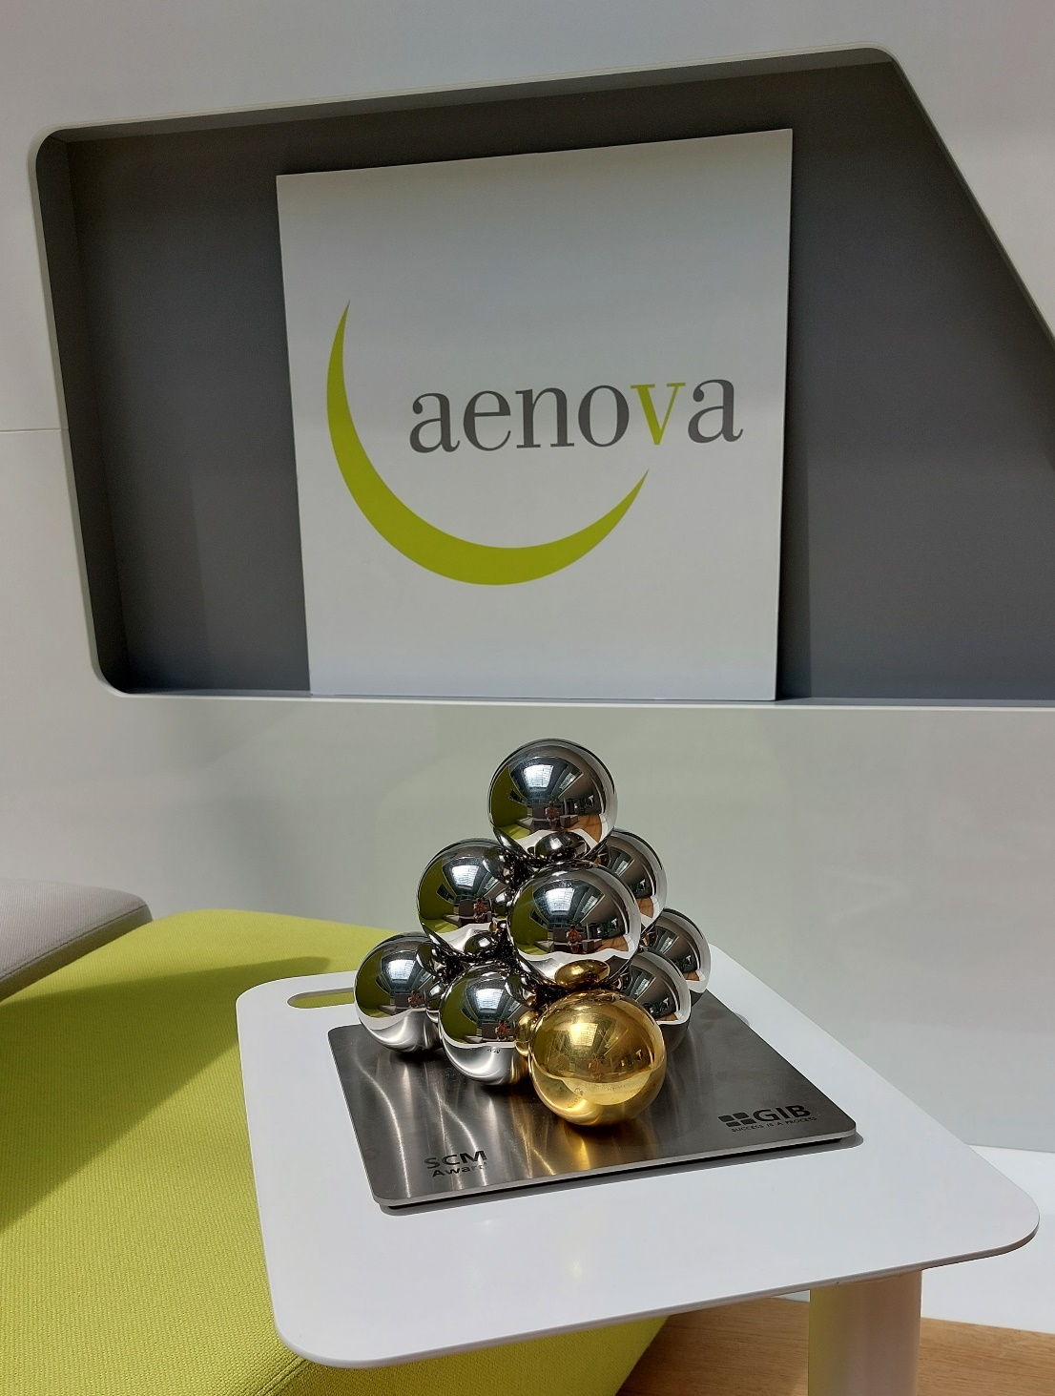

Caption: Aenova has received a 2022 GIB Supply Chain Management Award for outstanding optimization in planning and scheduling. (Photo: Aenova)

**About Aenova Group**

The Aenova Group is a leading global contract manufacturer and development service provider for the pharmaceutical and healthcare industry. As a one-stop store, Aenova develops, produces and­ packages all common dosage forms, product groups and active ingredient classes from pharmaceuticals to dietary supplements for human and animal health: solid, semi-solid and liquid, sterile and non-sterile, high and low dose, OEB 1 to 5 (Occupational Exposure Band). Approximately 4,200 employees at 16 sites in Europe and the U.S. contribute to the company's success. For more information, visit www.aenova-group.com.

**Press contact**

Dr. Susanne Knabe  
Head of Corporate Communication & PR

Aenova Holding GmbH

Berger Straße 8 - 10

82319 Starnberg

Germany

Mobile: +49 170 22 368 42

E-mail: [susanne.knabe@aenova-group.com](mailto:susanne.knabe@aenova-group.com)