PRESS RELEASE

Commitment to diversity

Aenova signs "Diversity Charter"

- Aenova, global leading contract development and manufacturing organisation for the pharmaceutical and healthcare industries, signed the "Diversity Charter", a voluntary commitment to diversity, at the end of 2021.
- Through this commitment, the Aenova Group underscores its recognition of an appreciative work environment for all employees - regardless of, for example, their age, ethnic origin, nationality, gender identity or religion.
Starnberg, June 03, 2022 - The diversity of society is increasingly shaping the world of work, not only in Germany but also worldwide. Companies can only be successful today if they recognize, promote and know how to use this diversity. Because the diversity of all employees with their different skills and talents opens up opportunities for in novative and creative solutions.

The Aenova Group is now one of the signatories of the employer initiative "Diversity Charter" since the end of the year 2021. The Aenova Group currently employs around 4,200 people from 53 nations at its 16 sites worldwide, almost equal numbers of women and men, across a wide range of educational, hierarchical and age levels. "We are pleased that by signing the 'Diversity Charter' we can now demonstrate even more clearly our understanding of diversity in our company, which we have already been living on a daily basis for a long time," explains Marcella Spagnuolo, Vice President Corporate HR International and responsible for the "Diversity Charter" at Aenova.

"Our goal is to implement our values-driven culture, based on respect and appreciation, even deeper within the company," comments Tim Bauer, Senior Vice President Corporate HR at Aenova Group. "This started last year with our values rollout and will continue with a wide variety of HR measures, such as our new feedback and development processes, to ensure our employees can best develop their diverse skills and talents."

The "Diversity Charter" is an employer initiative to promote diversity in companies and institutions. The aim of the initiative is to promote the recognition, appreciation and inclusion of diversity in the world of work in Germany. Organizations should create a working environment that is free of prejudice and all employees should be valued - regardless of age, ethnic origin and nationality, gender and gender identity, physical and mental abilities, religion and worldview, sexual orientation and social origin. Since 2010, the initiative has been supported by the non-profit association Charta der Vielfalt e. V. Many well-known large corporations, medium-sized companies and other institutions are among the signatories.

"At Aenova, we are convinced that living diversity and valuing it has a positive impact on the organization and on society," sums up Tim Bauer.

For more information on the "Diversity Charter," visit www.charta-der-vielfalt.de .

Image material
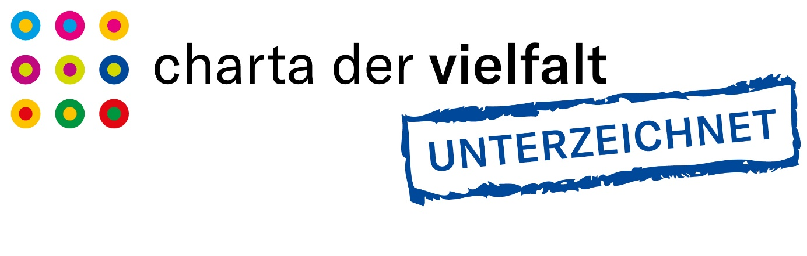
BU: At the end of 2021, Aenova signed the "Diversity Charter", a self-commitment declaration on diversity.

About Aenova Group

The Aenova Group is a leading global contract manufacturer and development service provider for the pharmaceutical and healthcare industry. As a one-stop store, Aenova develops, produces and packages all common dosage forms, product groups and active ingredient classes from pharmaceuticals to dietary supplements for human and animal health: solid, semi-solid and liquid, sterile and non-sterile, high and low dose, OEB 1 to 5 (Occupational Exposure Band). Approximately 4,300 employees at 16 sites in Europe and the U.S. contribute to the company's success. For more information, visit www.aenova-group.com.

Press contact

Dr. Susanne Knabe
Head of Corporate Communication & PR
Aenova Holding GmbH
Berger Straße 8 - 10
D-82319 Starnberg

Mobile: +49 170 22 368 42
E-mail: susanne.knabe@aenova-group.com

